**Program 15:-**

**Using OR:-**

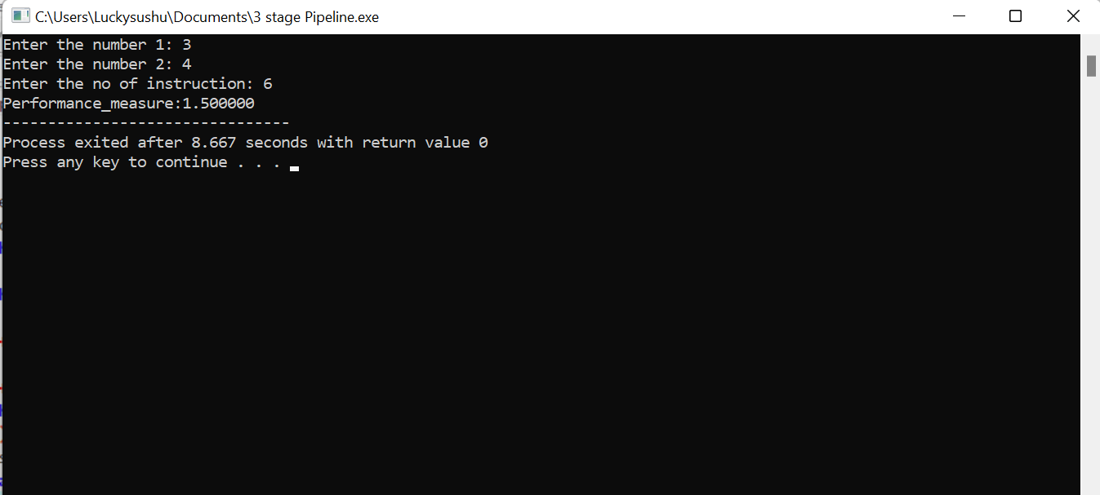

**Using AND :-**

